Intra-articular Viscosupplementation Injections

What is it?
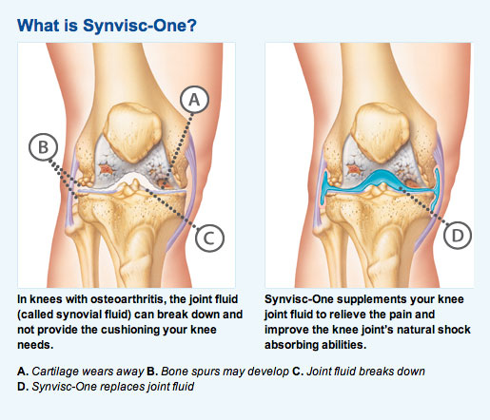
Viscosupplementation is a procedure in which a thick, gel-like substance is injected into a joint (intra-articular). These substances, known as hyaluronates (hyaluronic acid and hylan), improve the lubricating properties of the natural fluid in the joint (synovial fluid), reduce joint pain, improve mobility, and provide a higher and more comfortable level of activity.
A. Cartilage wears away B. Bone spurs may develop C. Joint fluid breaks down
D. Intra-articular Viscosupplementation replaces joint fluid

What is it used for?
Intra-articular hyaluronic acid injections are a treatment option for chronic, symptomatic osteoarthritis (OA) when a patient has not found sustained pain relief from other therapies such as weight loss, physical therapy, corticosteroid injections, or cannot tolerate oral pain medications or NSAIDs. It is used mainly in the treatment of OA of the knee, but has increasingly been used in other joints.

How is it performed?
Viscosupplementation is a simple outpatient procedure. There are several approaches to inject viscosupplements into the knee joint. The patient will be comfortably placed on the exam table while the area to be injected will be cleaned in order to decrease risk of infection. Generally, a physician will inject the viscosupplements into the knee by simply using landmarks of the joint. While this is a common approach, we utilize imaging technology (ultrasound) to perform the procedure. To be optimally effective, the hyaluronate injection must be placed directly into the joint space that contains articular cartilage and joint fluid. By use of ultrasound guidance, our physicians are 100% certain that the supplementation gets to its precise location to ensure the best outcomes for the patient.
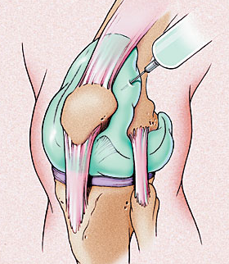
What do I do after the procedure?
Unlike other injections, viscosupplementation does not have any numbing agents in the substance. Therefore, there may not be instant relief in pain after the injection. No excessive weight-bearing physical activity should take place for 1-2 days following the injection. Initial swelling, warmth and redness 1-2 days after the procedure at the site of the injection, is likely due to the body’s normal response to the injection. You may want to apply ice and elevate the area to help ease these symptoms. If after 5-7 days the swelling does not improve and the injection site becomes warm, drains pus, and you experience fevers, it is advised that you go to the emergency room. Some feel immediate improvement but typically the most is expected from 2 to 13 weeks after the injection with effects lasting 6 months or hopefully longer. For patients whose condition does not respond, it is important to continue treatment with consideration of non-pharmacologic (i.e. physical therapy) as well as pharmacologic options. The effect of intra-articular hyaluronate on the structural improvement of OA, especially after repeat administration over longer intervals, remains an open question.

What are the possible risks?
In most of the trials of hyaluronic acid (HA) and hylan, rates of adverse reactions have been low (generally zero to 3 percent) and no systemic reactions were attributed to hyaluronates. Most of the reported adverse reactions consisted of minor localized pain, warmth or joint swelling, which was resolved within one to three days. It is unclear whether these local reactions were caused by the hyaluronic acid itself or by the injection procedure. Infection and bleeding are also rare complications. No long-term side effects have been reported. Inform your provider if you are allergic to eggs or feathers.

How often should this procedure be done?
Injection schedules differ between products. There is an option for a single dose every six months and a three to five dose regimen with a one week interval between each injection. There are no cures for OA; therefore viscosupplementation will not cure OA. One study suggests that a lack of response to an initial course of intra-articular hyaluronate does not necessarily mean that a repeat course will not be effective. The FDA has approved repeat courses of intra-articular hyaluronate; however, many insurance plans require at least a 6-month interval between treatments.

