TRIGGER POINTS

Trigger points are tight areas, or “knots” within muscle tissue that can cause pain in other parts of the body. Normally, they occur either within the muscle itself or within the surrounding fascia, and often are very painful. There is much research currently on going to discover the nature of trigger points.
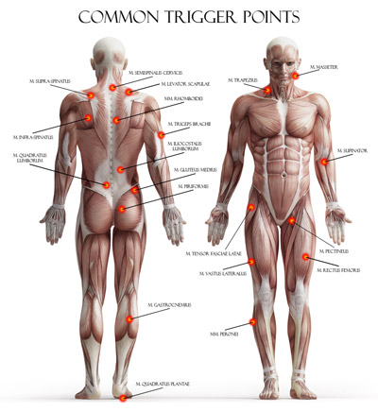

Why do I get trigger points? The short answer is that no one knows for certain as of yet. However, they are most likely due to a number of factors, including short term and long-term muscle overload, systemic inflammation, certain diseases, direct trauma to the area, and even smoking.

What are the signs and symptoms? Trigger points can be palpated by a trained physician. Often, there is a palpable nodule or “knot” in a tight muscle. Pressing on these points can cause pain, especially in different areas of the body. For example, a trigger point in a back muscle, when compressed, can cause referred pain into the neck. There can also be local tenderness over the tight musculature, as well as twitching at the site of the trigger point. When a trigger point is present in a muscle, there can also be pain and weakness of the surrounding structures.

How are trigger points treated? Trigger points can be treated in a couple of different ways:

- Physical Manipulation – A trained physician can both diagnose and treat trigger points with their hands. This can involve a variety of techniques such as Osteopathic Manipulative Treatment (OMT), deep pressure, mechanical vibration, stretching, electrostimulation, muscle energy, counterstrain, and myofascial release.

- Injection – If necessary, your doctor can attempt a variety of injections to resolve the trigger point, ranging from simple “dry needling” (sticking the point with a needle) to injections with local anesthetics like lidocaine.

What can I do on my own? Massage has shown to be helpful to many patients with trigger
points, either a professional massage clinic or self-massage. Self-massage can be performed with your fingers, hands, elbows, tennis ball, foam roller, TheraCane, tennis ball, or any other handy household objects you can find. Talk to you doctor about what treatment options are best for you!

