Use of the Theraband Flex-Bar®

for Tennis Elbow and Golfer's Elbow

What is “tennis elbow” (lateral epicondylalgia)?
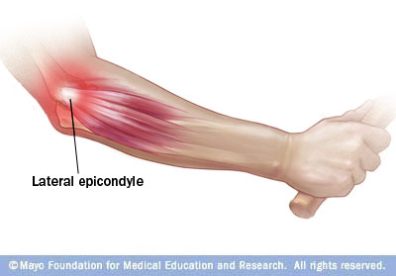
Tennis elbow, or lateral epicondylitis, is a painful condition of the lateral elbow caused by overuse of the forearm muscles and tendons like in backhand motions performed in tennis. The most common muscle involved in tennis elbow is called the Extensor Carpi Radialis Brevis (ECRB). The ECRB can be at increased risk for damage because of its position. As the elbow bends and straightens, the muscle rubs against bony bumps. This can cause gradual wear and tear of the muscle over time.
Most people who get tennis elbow are between the ages of 30 and 50, although anyone can get tennis elbow if they have the risk factors. In racquet sports like tennis, improper stroke technique and improper equipment may be risk factors.
The symptoms are often worsened with forearm activity, such as holding a racquet, turning a wrench, or shaking hands. Your dominant arm is most often affected; however both arms can be affected.

What is “golfer's elbow” (medial epicondylalgia)?
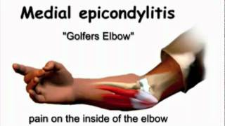
Most golf injuries are the result of overuse. By repeating the same golf swing motion over and over again, significant stress is placed on the same muscles, tendons, and joints. Many other repetitive activities can also lead to golfer's elbow: throwing, chopping wood with an ax, running a chain saw, and using many types of hand tools. Any activities that stress the same forearm muscles can cause symptoms of golfer's elbow. Over time, this can cause injury. Golfer's elbow is an inflammation of the tendons that attach your forearm muscles to the inside of the bone at your elbow. One of the best ways to avoid elbow problems is to strengthen your forearm muscles and slow your golf swing so that there will be less shock in the arm when the ball is hit.

The muscles involved in medial epicondylitis primarily include the pronator teres and the flexor carpi radialis. Less likely to be involved are the palmaris longus, the flexor digitorum superficialis, and the flexor carpi ulnaris. The anterior-medial epicondyle is the primary area of involvement with this condition.

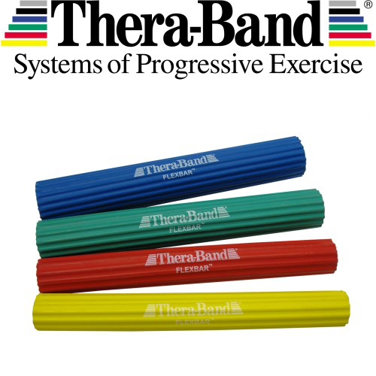
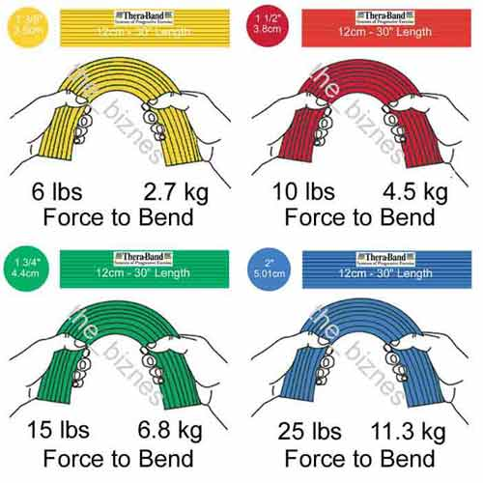
How does the TheraBand™FlexBar® work?
The TheraBand™FlexBar® is a flexible, durable resistance device with a ridged surface for enhanced grip during use. It is used to improve grip strength and upper extremity stabilization by bending, twisting, or oscillation movement. It comes in various tensile strengths sorted by color:

TheraBand™FlexBar® Tyler Twist for Tennis Elbow
For lateral epicondylitis, the FlexBar will help with rehabilitation of the wrist extensor muscles by eccentric loading. Eccentric loading is muscle lengthening while being contracted.
Step 1: Grasp the FlexBar in front of you with the injured side and extend your wrist.
Step 2: Grasp the upper end of the bar with your other hand facing away from you.
Step 3: Twist the bar with the top hand while you stabilize with the bottom hand.
Step 4: Hold both wrists steady as you extend both elbows in front of you. The wrist on your injured side should be extended and the other wrist flexed.
Step 5: Slowly release the bar with your injured side while maintaining tension with the uninjured side.
Repeat 10-15 times up to 3 times a day. Begin with the red FlexBar and progress to the next color when you can easily perform 3 sets of 15. Use ice or Biofreeze for any soreness.

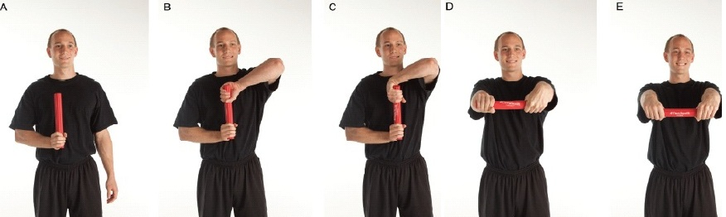

TheraBand™FlexBar® Reverse Tyler Twist for Golfers Elbow:
For medial epicondylitis, the TheraBand™FlexBar® will help with rehabilitation of the wrist flexor muscles, also by eccentric loading.

Step 1: Grasp FlexBar® exerciser with the injured side, bending your elbow and holding the bar parallel to the ground.
Step 2: Lift the elbow of your un-injured side upward and rotate your forearm so your palm faces away from you.
Step 3: Grasp the other end of the FlexBar with the un-injured hand facing away from you and pointing downward
Step 4:Twist the FlexBar with the hand on the un-injured side as you stabilize with the injured-side hand
Step 5: Hold both wrists steady as you extend both elbows in front of you. The wrist on your injured side should be flexed toward you and the other wrist extended.
Step 6: Slowly release the FlexBar with your injured side while maintaining tension with the uninjured side
Repeat 10-15 times up to 3 times a day. Begin with the red FlexBar and progress to the next color when you can easily perform 3 sets of 15. Use ice or Biofreeze for any soreness.

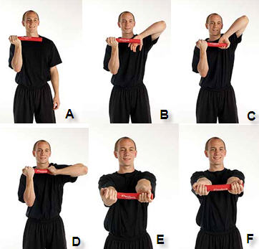

TheraBand™FlexBar® exercises: https://www.youtube.com/watch?v=MYMu3d7QNyg

