Use of the Thera Cane®

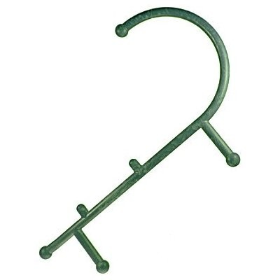
What is a trigger point?
A trigger point is an area of hypersensitivity, usually located within a taut band of skeletal muscle or within the muscle fascia itself. It is typically painful upon compression and can give rise to characteristic referred pain, tenderness, and autonomic phenomena. Trigger points originate from muscular injuries, strains, trauma, structural imbalances, improper body mechanics, poor nutrition, mental stress, or emotional stress. Small tears in the soft tissue may develop when muscle fibers, fascia, ligaments or tendons become weakened, overstretched, or inflamed. As the body compensates for this imbalance, the muscle tissue may contract resulting in localized areas of muscle that are twisted and knotted. This leads to a restriction of oxygen-rich blood flow within these knotted fibers. Additionally, the body’s natural mechanism to protect an “injured” structure is often to shorten that particular muscle to prevent further injury. This may further result in decreased range of motion of a particular joint and an increased likelihood that the muscle and associated structures will develop trigger points.
How does the Thera Cane work?
The Thera Cane works by applying direct pressure to trigger points within problematic muscles which results in increased flow of oxygen-rich blood to the muscles. This direct pressure also may break up adhesions within muscle fibers and tendons thus improving muscle function. The Thera Cane allows an individual to apply deep pressure massage to any area of the body (e.g. back, neck, shoulders, legs, hips, arms, and buttocks) to relieve pain and improve muscle function.
How to use the Thera Cane?
For All Neck Exercises:
- Lean your neck into the ball while keeping your hands and the Thera Cane still
- Move your neck side to side as well as up and down while you apply pressure
- Experiment while in the supine position (laying down on your back) with your head slightly elevated
- Use your fingers for the muscles in the front of your neck
For All Shoulder Exercises:
- Push down in the direction of the arrows for pressure
- Move arms back and forth, 1-2 inches across the muscle
- Keep your arms in close to your sides to avoid fatigue

Neck & Shoulder:
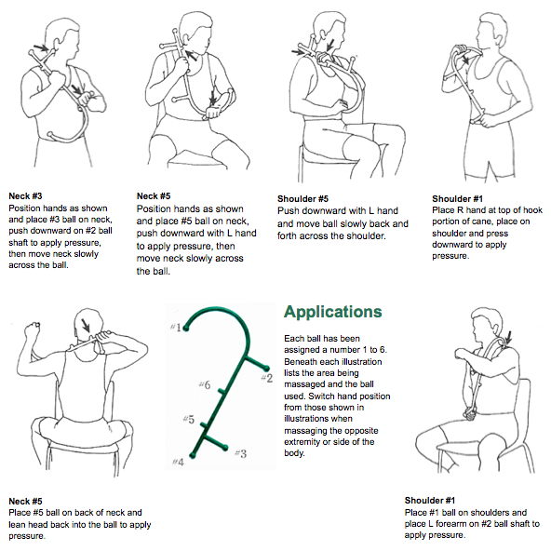For All Back Exercises:
- Push down in the direction of the arrows
- When using against a chair, stabilize the Thera Cane then move side to side for cross friction massage
- For larger individuals:
  - Keep back and buttocks 2-3 inches form the back of the chair
  - Keep the Thera Cane held off to the side
  - Move side to side for cross friction massage

Back:
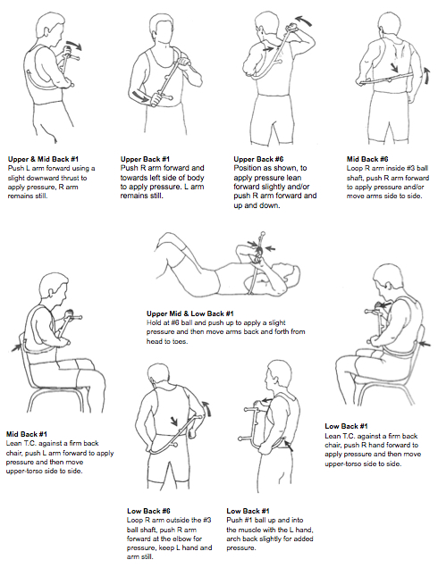

For All Arm Exercises:
- Stabilize the Thera Cane as shown in the illustrations
- Shift body weight into ball for more pressure
Arms:
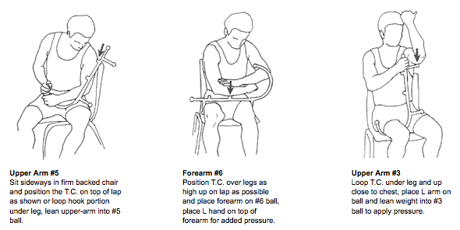

For All Leg Exercises:
- Position the Thera Cane as shown in the illustrations to help develop your skills
- Keep the upper half of the Thera Cane still and let it act as a pivot point
Legs:
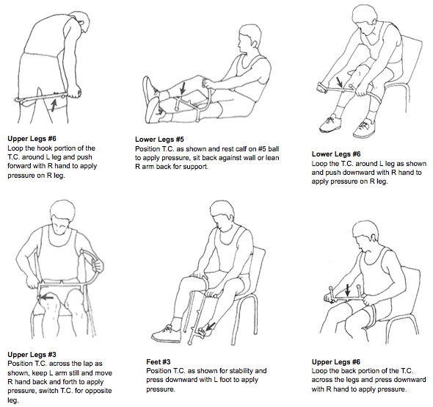

For All Core Exercises:
- Lean into the ball for pressure
- Take advantage of the leverage whenever possible
Core:
