TARSAL TUNNEL SYNDROME

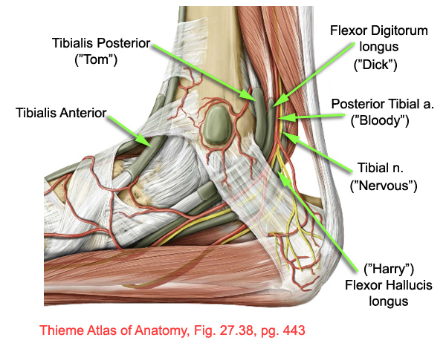
What is the tarsal tunnel?
The tarsal tunnel consists of 5 structures: 3 tendons, the posterior tibial artery and the tibial nerve. These structures all run in the same tunnel behind a ligament called the flexor retinaculum (red arrow pointing to white structure). The flexor retinaculum keeps these structures in proper alignment.

What causes it?
Tarsal tunnel syndrome is the result of overcrowding within the tarsal tunnel. Overcrowding can be caused by ankle fractures, rheumatoid arthritis and other causes of inflammation such as overuse of certain muscles. When overcrowding starts to occur, it can push on the tibial nerve. As a result the nerve becomes irritated causing the symptoms of tarsal tunnel syndrome.

What are the symptoms of tarsal tunnel syndrome?
Tarsal tunnel syndrome typically present with aching, burning, numbness, and tingling involving the sole of the foot, the distal foot, the toes, and occasionally the heel. The pain may radiate up to the calf or higher. The discomfort is often most irritating at night, may be worse after standing, and sometimes leads to the desire to remove the shoes, even while driving.¹

What treatments are available?
Conservative treatment is typically tried first. This consists of nonsteroidal anti-inflammatory drugs (NSAIDs), shoe modification, physical therapy, and in some cases orthotics. If conservative treatment does not work for you, your doctor may try a corticosteroid injection or a nerve hydrodissection procedure (performed in office under ultrasound guidance). Surgery is a last option.²

References:
¹ McManis PG. Sciatic nerve lesions during cardiac surgery. Neurology 1994; 44:684.
² Macaré van Maurik JF, Schouten ME, ten Katen I, et al. Ultrasound findings after surgical decompression of the tarsal tunnel in patients with painful diabetic polyneuropathy: a prospective randomized study. Diabetes Care 2014; 37:767.

