Shoulder and Scapular Stabilization Exercises

Purpose of Improving Range of Motion, Strengthening Muscle, and Positional Retraining:
After sustaining an injury to the shoulder, it is important to sequentially retrain the muscles around the shoulder and scapula (shoulder blade) to conduct proper movements. Without doing so, a muscle imbalance can develop as the body learns to avoid using the injured area. Over time this can lead to increased pain, decreased range of motion, and difficulty with daily activities due to overworking the surrounding muscles and ligaments. Proper rehabilitation of the shoulder requires proprioceptive retraining, increasing range of motion in all planes, and strengthening the shoulder stabilizers (rotator cuff muscles and scapular stabilizers). One should anticipate 4-6 weeks of rehabilitation. Afterwards, a continued maintenance program will be necessary to ensure lifelong protection of your shoulders.
Proprioceptive Retraining
Proprioception is the ability to know where your limbs are in space at any moment in time. Injury to a limb can lead to a disruption in this ability. Prior to strength training, your Physical Therapist or physician will provide you various balance exercises to retrain you in this ability. Those with injury requiring surgery and/or long periods of disuse will likely need more extensive proprioceptive retraining. One such exercise can be found by going to the QR code to the right:
While squeezing the shoulder blades together and downward, stand facing a wall and use the injured arm to bounce a lightweight ball against the wall at a distance of 1-3 inches. Move the injured arm to various points to retrain fine motor control of your arm.
Range of Motion
Prior to strength training it is important to have the flexibility required to do the exercises correctly. This in turn will minimize potential re-injury and improper muscle recruitment. Gentle stretching should be done multiple times per day. The stretch should be to the point of slight discomfort, never to pain. See below for some example stretches.
Strengthening Exercises
Shoulder and scapular strengthening exercises should be started only when full range of motion has been attained. See below for exercises that can be done to improve stability around the shoulder joint, as well as improve scapular motion.

IMPORTANT!
- It should be noted that during rehabilitation, exercises involving active range of motion of the shoulder are encouraged, but certain daily activities should be avoided – especially those involving overhead lifting, or lifting with elbows in full extension (lifting away from your body).
- If an exercise ever becomes painful, STOP IMMEDIATELY. Decrease your repetitions until you can comfortably conduct each exercise. If you are having difficulty with multiple strengthening exercises or severe pain, consult your physician.
- Your arm should not be immobilized unless directed by your physician.
- Use of ice and non-steroidal anti-inflammatory drugs (NSAIDs) such as ibuprofen (Motrin) or naproxen (Aleve) can complement therapy. These, as with all medications, should be used as recommended by your physician.

Stretches:
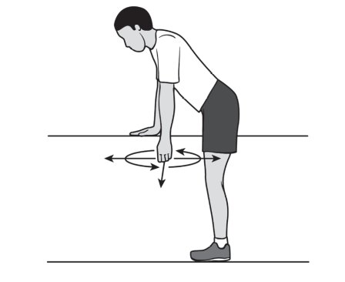

- Pendulum Swing – Bend forward 90 degrees at the waist, using a stable surface such as a table for support. Let arm swing in a circular pattern clockwise 10 times, then counterclockwise 10 times.
Image Source: American Academy of Orthopaedic Surgeons
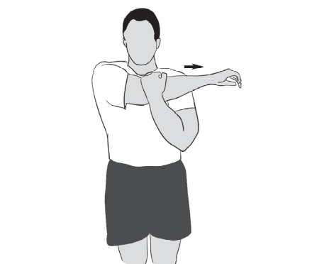
- Crossover Arm Stretch – Gently stretch your arm across your chest, holding at your upper arm instead of below your elbow. Hold for 30 seconds then relax for 30 seconds. Repeat multiple times throughout the day.
Image Source: American Academy of Orthopaedic Surgeons

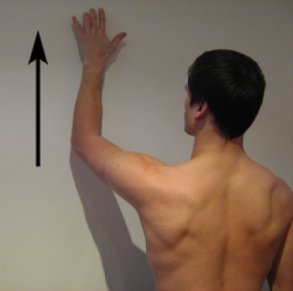
- Finger walk / Wall-walk – Standing at a 45 degree angle to the wall, the arm closest to the wall is extended making contact with finger tips. Use fingers to "crawl" up wall as far as possible holding 10 seconds at the top.
Image Source: www.physioadvisor.com.au

Strengthening Exercises:
Rotator Cuff Muscles:
Perform all of these in standing position with shoulder blades pinched and shoulders down.
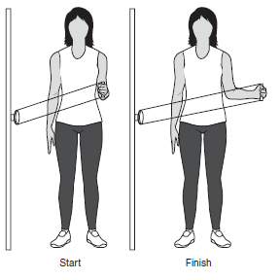
- External rotation using Thera-band – Attach Thera-band to stable object. Stand with injured arm furthest from object, holding the band with your elbow bent at your side, hand straight out in front of you. Keeping your elbow at your side, rotate your arm outward, pulling the band away from your body. Strengthens: teres minor
Image Source: American Academy of Orthopaedic Surgeons
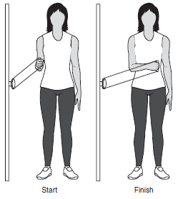
- Internal rotation using Thera-band – Attach Thera-band to stable object. Stand with injured arm closest to object, holding the band with your elbow bent at your side, hand straight out in front of you. Rotate your arm inward. Strengthens: subscapularis

Image Source: American Academy of Orthopaedic Surgeons

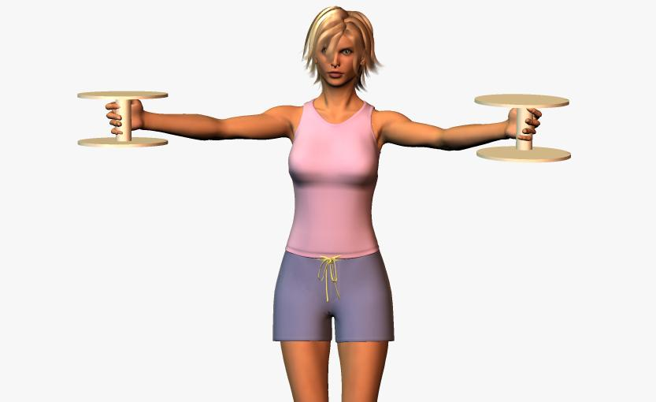
- Full can straight arm lifts. Begin with your arms straight at your side and your thumbs pointed up and then raise your arms overhead in a 45-degree position (halfway between your front and your side). Keep your elbows straight throughout the movement.
Strengthens: supraspinatus
Image Source: www.dynoswim.com
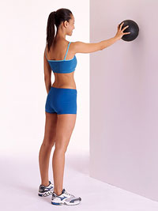

- Ball on the wall – With arm extended, roll a ball in a circle against the wall. Strengthens: stabilizers of rotator cuff and scapula
Image Source: www.fitnessmagazine.com

Scapular Stabilizers:
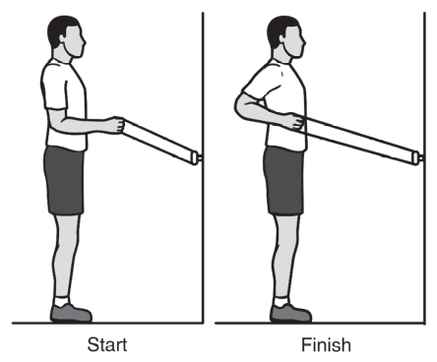
- Standing/Seated row using Thera-band – Attach looped Thera-band to stable object slightly below chest level. Keeping your shoulder and elbow level, slowly retract your shoulders and hold position. This should be felt between your shoulder blades, NOT your neck and shoulders. Strengthens: rhomboids

Image Source: American Academy of Orthopaedic Surgeons

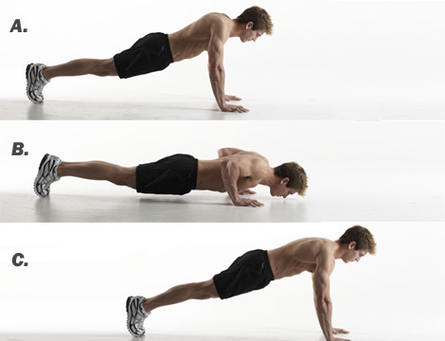
- Push-ups with a plus – Like a traditional push-up, except as you straighten your arms, push your upper back toward the ceiling. This extra movement is small. Initially perform against a wall while standing, then on the knees, then finally in a traditional push-up position. Strengthens: serratus anterior
Image Source: www.menshealth.com

- Hughston Shoulder Exercises: To be done lying down on the floor or a table. Begin with 1 set of 10 reps daily, progressing to 1 set of 60 reps total. Complete each action, return to start point and repeat.
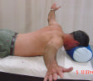
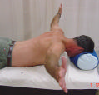
  - Raise arms so they are parallel to the floor but perpendicular to your body (letter T). Point thumbs forward towards your head and squeeze shoulder blades together. Do not let arms drop to floor. Strengthens trapezius & rhomboids
b
a
  - Same as (a), but with thumbs pointing up towards ceiling. Strengthens infraspinatus
c
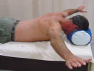
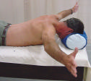
  - Bring arms forward to form a letter Y. Without shrugging shoulders towards your head, bring arms up towards ceiling as far as possible. Strengthens supraspinatus, trapezius & rhomboids
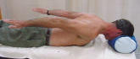
  - Same as (c), but with thumbs up towards ceiling.
Strengthens trapezius & rhomboids
d
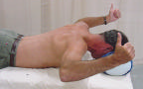
  - Bring arms to your side, palms down. Lift arms up towards ceiling as far as possible.
Strengthens teres minor, trapezius & rhomboids
e
  - Bring arms back to a T. Bend your elbow and externally rotate your shoulder (as if cocking to throw a ball). Strengthens infraspinatus, teres minor, trapezius & rhomboids
f

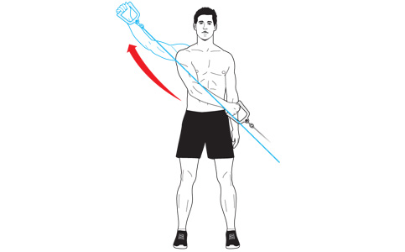
- Hitchhiker – While standing, begin with arm across your body at the opposite hip with the thumb pointed down. Keeping your trunk still, draw your straightened arm back across and outward away from your body, ending with your thumb pointed up.
Strengthens: deltoids, infraspinatus, teres minor
Image Source: www.menshealth.com

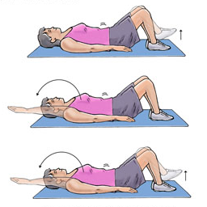
Abdominal and Low Back Muscles:
- Dead bug – performed lying flat on the back with hands under the pelvis/back. Simultaneously lift one leg while extending the opposite arm, lower both, and then switch sides.
Strengthens: abdominal core muscles
Image Source: www.summitmedicalgroup.com

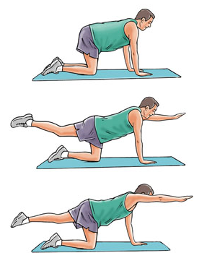
- Quadruped – performed on all fours, lift arm and opposite leg simultaneously. Perform with eyes closed to better develop balance and stability. Strengthens: lower back and abdominal core muscles
Image Source: www.summitmedicalgroup.com

