Proper Shoe Fitting Instructions

Every individual has a unique shape to their feet and thus it is important to have shoes that are fitted accordingly to spare one from injury, blisters, calluses and skeletal misalignment. Furthermore, keeping out of harm’s way allows one to keep active and exercising. The most common conditions caused by improperly fitted shoes include bunions, plantar fasciitis, Morton’s neuromas and hammer toes.

Proper shoe fitting:
- Have each foot measured in both length and width. It is quite common, in fact, to have unequal measurements between feet. The front of the shoe should allow for the toes to spread and the end of your big toe should have around a quarter to half an inch space from the end of the shoe when standing up.
- Measure the arch of each foot. It is imperative for the arch of the shoe to firmly match your own. This will aid in avoiding the most common injuries from calluses to plantar fasciitis.
- The ball of your foot should fit like a glove. There should be minimal slippage and this is the strongest controller.
- Know the shape of your foot. This ties together the various measurements allowing for even wear of the soles and not on you.
- Your feet swell over the course of a day. Try to avoid the extremes of the day when measuring your feet.
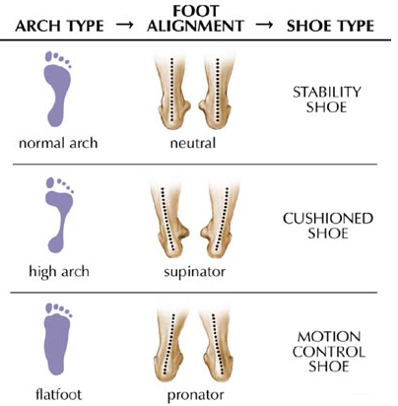

Things to keep in mind while shoe shopping:
- Seek out an establishment that specializes in shoe fitting.
- Clarify what type of shoe desired, walking or running.
- Try on shoes with the socks they’ll normally be worn with.
- Walk or jog around simulating the activities in which the shoes will be used.
- Invest in your health regularly and know when it is time to replace worn down shoes.
- Your feet change as you grow older as obvious as this may seem so make sure you are changing shoes accordingly.

