Postural Retraining Exercises

What is Posture?
Posture, or the way we carry ourselves, is something we develop over time. Any injuries, congenital abnormalities, and even our work environment influence our posture. A good posture tends to distribute weight evenly among your joints, but a bad posture can lead to aches and pains as some joints are loaded with more weight than others. It is something our body does subconsciously; as such postural re-training is not corrected overnight. Postural training requires weeks of strengthening, and months of conditioning before our bodies start forgetting old postural habits. A little work each day leads us to use better posture and improve pain in the process.

DAILY EXERCISE: Have a co-worker/family member/friend observe your posture and tell you when it is not correct. This is especially helpful when you are not expecting it as it reminds you that your posture is not where it should be. This can also be done by having a mirror next to your workspace.

These Exercises are to be performed to the best of your ability. Stop and reposition any exercise causing excessive pain. Listen to your body, it will tell you how far you can push yourself.

Sway Back
- Problem: tight hamstrings with decreased curvature of lower back
- Exercises to perform:
  - Stretching Tight Hamstrings
    - Lie on your back
    - With your buttock and legs against
a wall in an L position
    - Take slow deep breaths
    - You can also do this stretch with a strap around your foot to reproduce the “L” position.
  - Locust pose – for decreased curvature of lower back
*use a blanket or a yoga mat to lie on
    - Lie on your belly with your arms at your
side – palms up and forehead on the floor
    - Lift your head, upper torso, arms, and legs
toward the ceiling
    - Hold for 5 seconds and repeat 10 times
  - Cobra pose – encourages curvature of lower back
* use a blanket or a yoga mat to lie on
    - Lie on your belly
    - Push upper body up towards the ceiling
- stretch shoulder from your ears but do not
throw your head back
    - Hold for 5 seconds and repeat 10 times

Lumbar Lordosis
- Problem: Tight hip flexors and hamstrings with weak abdominal muscles.
  - Supported standing lunge – for tight hip flexors
    - Stand facing a wall in a lunge position
with directly over your heel
    - Your back leg should be bent at first,
but it should be straightened for an
increased stretch.
-Try to widen your stance when possible
for stability
  - Bridge pose
    - Lie on your back with knees bent and feet on the floor
    - Lift your hips to the ceiling
    - Hold of 5 seconds and repeat 10 times
  - Tight Hamstrings- See above
  - Abdominal muscle exercise – Partial Curl
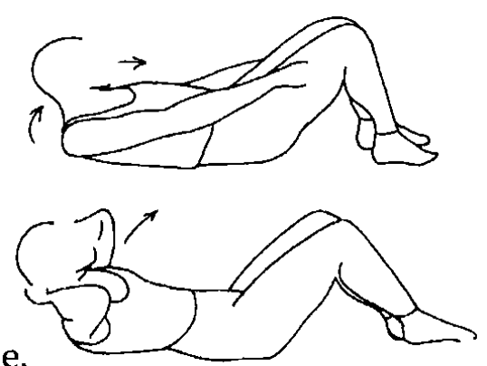
    - Lie on your back with knees bent
and feet flat on the floor
    - Tighten your abdominal stomach muscles
and flatten your back
    - Tuck your chin to your chest
    - Stretch your hands in front of you and
curl your upper body forward to clear your
shoulders from the floor
    - Hold for 3seconds, repeat 3 sets
*remember to breath

Thoracic Kyphosis
- Problem: Tight hamstrings, tight pectoralis muscles, weak rhomboids and latissimus dorsi
  - Locust pose as above
  - Hamstring stretch as above

  - Rhomboid strengthening - Using 5ft of tubing or a resistance band
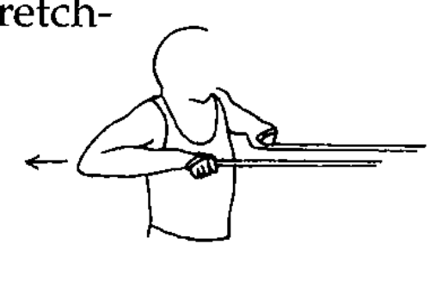
    - Shut the tubing or resistance band (with a knot)
behind a closed door at shoulder height
    - Standing at about 3 feet away from the door
    - Take the tubing in each hand and move elbows
and hands to shoulder height, parallel to the floor
    - Squeeze shoulder blades back, stretching the tubing
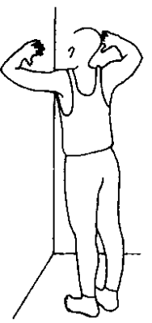
    - Hold for 5seconds and repeat 10 times
  - Pectoralis stretching
    - Stand in a door way or corner with
both arms on the wall slightly above your
head
    - Slowly lean forward until you feel a stretch
in the front of your shoulders
    - Hold 15 seconds and repeat 3 times

Forward Head
- Problem: Tight Hamstrings, tight neck extenders, weak neck flexors, weak intrinsic paravertebral muscles
  - Hamstring stretch from above
  - Pectoralis stretching from above
  - Locust pose from above
  - Neck stretching
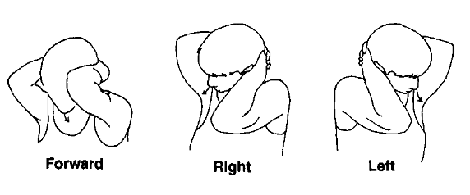
    - While sitting interlace your hands behind your head
    - Let the weight of your arms pull your
chin to your chest
    - Relax and hold for a count to 15,
repeat 3 times
    - Repeat this again while turning head right then left.

References:
Rouzier, P. (2004). The Sports Medicine Patient Advisor. Amherst, MA: McKesson Health Solutions LLC.

