Percutaneous Needle Tenotomy (PNT)

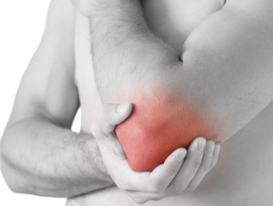
What is it?
Percutaneous needle tenotomy is a technique used to treat areas of chronic tendon degeneration (tendinosis), osteophytes (bone spurs), and calcific tendinosis.

Why is it used?
Most tendon injuries heal themselves. An injured tendon will initially develop tendinitis. If this persists, the body will stop attempting to heal the area and lay down scar tissue, which is non-functional, non-inflammatory, and painful; termed tendinosis. PNT is used to help the body’s innate healing abilities to repair the injured area by causing controlled inflammation to stimulate the healing process.

How is it performed?
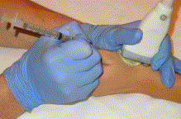
To ensure accuracy and safety, this procedure is done under ultrasound guidance. After a local skin anesthetic is applied to numb the injection site, a needle is inserted into the site of interest and directed towards the injured tissue. The needle will perform fenestration/trephination (poking) on the injured tissue at its insertion to the bony attachment (enthesis) to stimulate micro-trauma that will initiate the healing response. If there are calcifications or bone spurs, these may be obliterated with the needle during the procedure and will either be aspirated into the syringe or left to be absorbed by the body.

What happens after the procedure?
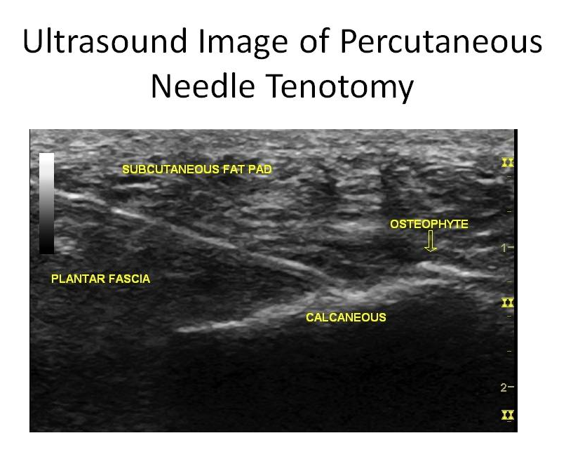
PNT can be very successful in relieving chronic tendinosis pain. After the procedure is performed we may immobilize the area for a couple of days to allow the healing process to occur. You will be given pain medication to help ease the pain after the procedure if warranted.

What diagnoses are typically treated with this?
Common tendinosis conditions include shoulder (rotator cuff tendinosis and calcific tendinosis), elbows (lateral epicondylosis, aka chronic tennis elbow), knees (patellar tendinosis), ankles (Achilles tendinosis), and foot (plantar fasciopathy).

What is the expected recovery?
After the procedure the area will be immobilized for a couple of days and then you will progressively rehabilitate the area to regain motion, strength and function. Recovery may take between 8-12 weeks after the procedure. You should have unlimited activity at that point.

