STRETCHING So important to your fitness, yet so often overlooked.  As children we learn to stretch in physical education class, but we’re already flexible and resilient. So, as we get older, we neglect stretching.  Result?    - Stiffness  - Muscle aches  - Injuries  When to stretch  This is a hot debate topic. Guidelines:  - Warm up briefly, then do a light stretching to run when your muscles are at optimum length.  - After your run, do some more vigorous stretching to ensure muscles are optimum length for healing.  Why warm up before stretching? Warm muscles are more flexible, but a cold muscle (such as right after you awaken) is more prone to micro-tears – the “cracks and pops” you feel when stretching.  Stretch after a warm shower or brief, light exercise.  If you have an injury and stretching is part of your treatment plan, it’s a good idea to stretch this area:  - In the morning and again in the evening before bed  - Before and after athletic activity that will put demand on this muscle  Which type of stretch is best? Static, passive, contract/relax, active isolated, dynamic – all are equally effective for flexibility. They key is to find a stretching model that you will do and maintain.  However, ballistic stretching (bouncing) is being phased out, as it has a greater incidence of injury  Duration: Most stretches should be held 15 to 30 seconds per repetition. | 3 Keys to Stay in Top Form… For the Long Run
 | 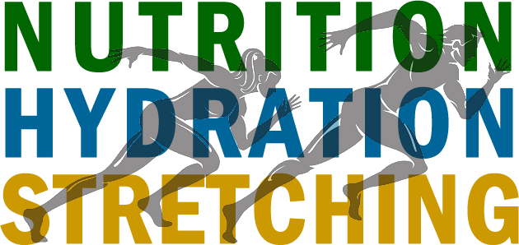
 | How to use them to stay on pace
 | 

NUTRITION Your pre-race/competition meal matters.  - Keeps you from feeling hungry before and during the race  - Maintains your blood-sugar level to fuel your muscles    What to eat, when  Your stomach shouldn’t be full, and it takes 1-4 hours to empty a meal into your intestines. The closer to the race time, the lighter your meal should be.  Three to four hours pre-race:  - Bread, bagels, baked potato, cereal with low-fat milk, low-fat yogurt or sandwich with little lean meat or low-fat cheese  - Fresh fruit (banana or apple), fruit juice or vegetable juice  - Up to 7.5 cups sports drink  Two to three hours pre-race:  - Bread, bagels, English muffins with limited butter, margarine or cream cheese, or low-fat yogurt  - Fresh fruit, fruit juice or vegetable juice  - Up to 4 cups of sports drink  One hour or less pre-race:  - Fresh fruit: apples, watermelon, peaches, grapes, oranges  - Fruit juice or vegetable juice: orange, tomato, V-8  - Up to 1.5 cups sports drink  What about sugar? Do what has work for you in the past; don’t experiment on race day!  Some sugary foods like energy bars, 35 to 40 minutes before your event, may help by feeding glucose to your muscles when your other energy stores have dropped. But quick peaks and valleys in blood sugar can harm performance.  What about caffeine? Its stimulant effect may improve performance, but caffeine has drawbacks for some runners:  - Increased urination leading to dehydration  - Nausea  - Muscle tremors  - headache | HYDRATION During your race, fluid replacement is one of your most importance concerns!    Your body is about 60 percent water. Dehydration lowers your blood volume. Each time your heart beats, it will pump less blood, and your exercising muscles won’t get enough oxygen.  What to drink, when  - 15 to 30 minutes before the race: 10 to 16 ounces cold fluid. A sports drink with a carbohydrate concentration of 6% to 8% helps store energy in muscles.  - Early in your run: Don’t wait till you feel thirsty to begin hydrating: by then you’ve lost 2% of your body weight.  - During your run: 4 to 8 ounces cold fluid every 10 to 15 minutes.  What to avoid:  - Carbonated drinks, which may upset your stomach  - Caffeinated drinks and alcohol, which increase urination and dehydration    Your sports drink should contain:  - A small amount of sodium (about 110mg per 8 ounces) and other electrolytes such as potassium and chloride  - 6% to 8% carbohydrate

