Nerve Hydrodissection

What is it?
Nerve hydrodissection is a technique used to free up pinched nerves to decrease pain and inflammation due to chronic nerve compression.

Why is it used?
Nerves normally glide through the muscles and soft tissue with movements. If injuries or repetitive stress occur, the nerves can get "stuck" and the tissue does not allow the normal motion. Pain and/or altered sensations can develop. Nerve hydrodissection can be used to free the nerve from the surrounding tissues.

How is it performed?
After a local skin anesthetic is applied to numb the injection site, a needle is inserted into the site of interest and directed towards the compressed nerve and its surrounding tissue. Then a dilute dextrose solution is delivered into the space to decrease the nerve inflammation as well as to separate the tissue from the nerve resulting in relief of pain. To ensure accuracy and safety, this procedure is done under ultrasound guidance.

What are the typical results?
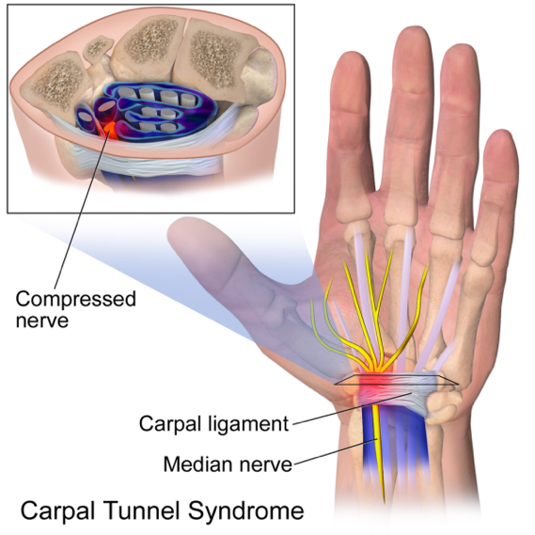
Nerve hydrodissection can be very successful in relieving pain. In fact, hydrodissection can provide substantial pain relief even when surgery fails. The benefit from this procedure will typically occur two to seven days following the procedure. This therapy combined with a routine of stretching allows many individuals to enjoy a pain free lifestyle.

What nerves are typically hydrodissected?
Median nerve associated with carpal tunnel syndrome
Ulnar nerve associated with cubital tunnel syndrome
Saphenous nerve associated with chronic knee pain
Posterior tibial nerve associated with tarsal tunnel syndrome
Suprascapular nerve associated with chronic shoulder pain

How often should this procedure be done?
This procedure may be repeated several times as needed to fully separate the nerve from its surrounding tissue. We will consider repeating the procedure every 3-4 weeks as needed until you are symptom free.

