Hydrodilatation with OMT
(Osteopathic Manipulative Treatment)

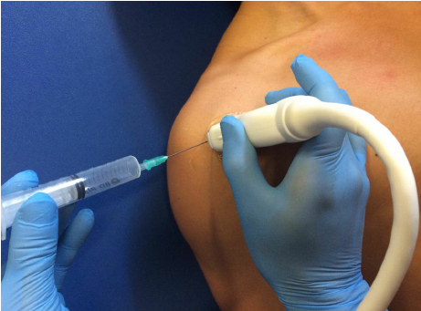
What is it?
Hydrodilatation is a technique using a liquid solution (hydro) to stretch the joint capsule (dilatation). Hydrodilatation of the joint capsule has been shown to increase range of motion around a joint and decrease pain. Combining hydrodilatation with osteopathic manipulative treatment (OMT) can improve the body’s natural healing ability, providing relief and improving overall function of the joint.

How is it performed?
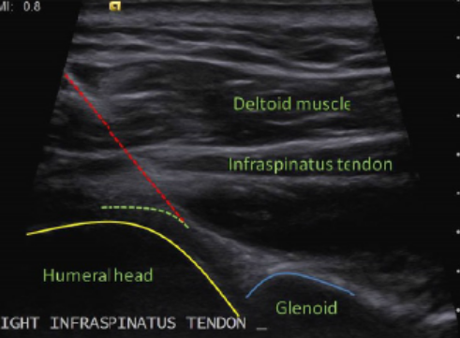
After a local skin anesthetic is applied to numb the injection site, a needle is inserted into the site of interest and directed in the joint capsule. Then a solution of dextrose, local anesthetic, and corticosteroid is delivered into the space to decrease the joint inflammation as well as to disrupt adhesions (scar tissue) resulting in relief of pain. To ensure accuracy and safety, this procedure is done under ultrasound guidance. OMT can then be performed under this local anesthesia and is a safe and effective alternative to surgical intervention to increase range of motion in joints with adhesive capsulitis “frozen joint”.

What are the typical results?
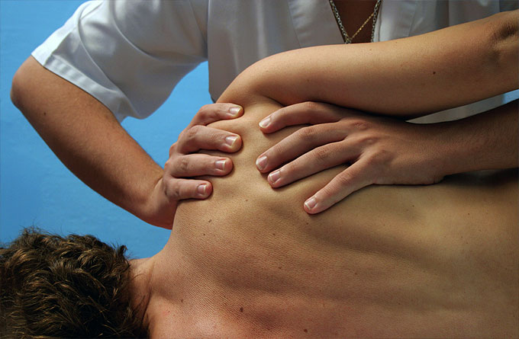
Hydrodilatation can be very successful in relieving pain and restoring motion. The benefit from this procedure will typically occur two to seven days following the procedure. This procedure combined with a routine of stretching allows many individuals to enjoy a pain free lifestyle without limitations of the affected joint.

What areas are typically hydrodilatated?
Hydrodilatation can be performed on large to intermediate joints. This includes the shoulder (adhesive capsulitis/frozen shoulder), elbow, hip, knee, and ankle.

How often should this procedure be done?
This procedure may be repeated several times as needed to fully stretch the joint capsule. We will consider repeating the procedure every 4-6 weeks as needed until you are symptom free.

