Fall Prevention


Falls Are Serious and Costly
- One out of five falls causes a serious injury such as broken bones or a head injury.
- Each year, 2.5 million older people are treated in emergency departments for fall injuries.
- Over 700,000 patients a year are hospitalized because of a fall injury, most often because of a head injury or hip fracture.
- Each year at least 250,000 older people are hospitalized for hip fractures.
- More than 95% of hip fractures are caused by falling, usually by falling sideways.
- Falls are the most common cause of traumatic brain injuries (TBI).

What Conditions Make You More Likely to Fall?
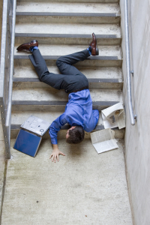
Many conditions can contribute to falling. These are called risk factors. They include:
- Lower body weakness
- Vitamin D deficiency (that is, not enough vitamin D in your system)
- Difficulties with walking and balance
- Use of medicines, such as tranquilizers, sedatives, or antidepressants. Even some over-the-counter medicines can affect balance and how steady you are on your feet.
- Vision problems
- Foot pain or poor footwear
- Home hazards or dangers such as:
  - Broken or uneven steps
  - Throw rugs or clutter that can be tripped over
  - No handrails along stairs or in the bathroom

Many risk factors can be changed or modified to help prevent falls

Lifestyle Choices to Prevent Falls

Understand Your Health and Medications
- Get an annual eye examination, and a physical that includes an evaluation for cardiac and blood pressure problems.
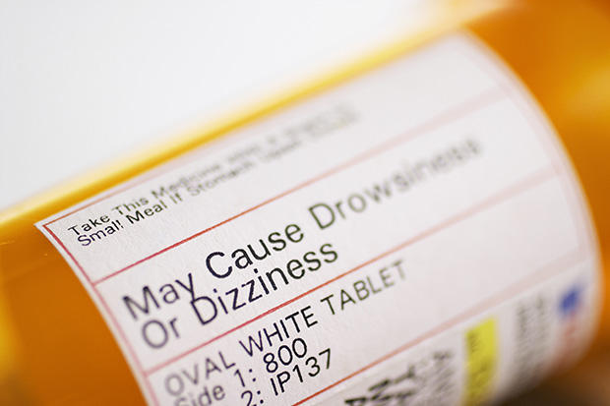
- Maintain a diet with adequate dietary calcium and Vitamin D.
- Do not smoke.
- Avoid excessive alcohol intake.
- Keep an up-to-date list of all medications and frequently provide it to all doctors with whom you consult.
- Check with your doctor(s) about any side effects of your medications and over-the-counter drugs, as fatigue or confusion increases your risk of falling.
- Make sure all medications are clearly labeled and stored in a well-lit area.
- Take medications on schedule with a full glass of water, unless otherwise instructed.

Exercise
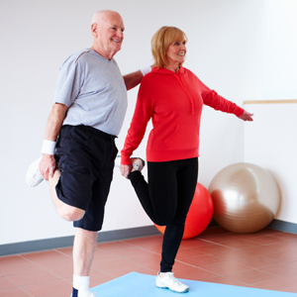
- Talk to your doctor about starting an exercise program.
- If possible, participate in an exercise program that aids agility, strength, balance, and coordination. Climbing stairs, jogging, hiking, dancing, weight training and other activities can help build bone strength and slow progression of osteoporosis, a disorder that causes bones to thin and weaken.
- In addition, active pastimes, such as bicycling and gardening, also can improve health and life quality.

Footwear
- Wear properly-fitting shoes with nonskid soles. Avoid high heels.
- Tie your shoe laces.
- Use a long-handled shoehorn if you have trouble putting on your shoes.
- Never walk in your stocking feet. Replace slippers that have stretched out of shape and are too loose

Home Modifications to Prevent Falls

Bedroom
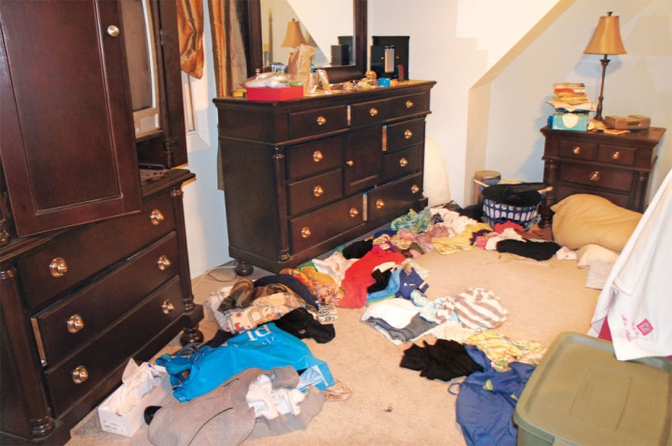
- Place a lamp, telephone, or flashlight near your bed.
- Sleep on a bed that is easy to get into and out of.
- Replace satiny sheets and comforters with products made of nonslippery material such as wool or cotton.
- Arrange clothes in your closet so that they are easy to reach.
- Install a nightlight along the route between your bedroom and the bathroom.
- Keep clutter off the bedroom floor.

Living Areas
- Arrange furniture so you have a clear pathway between rooms.
- Keep low-rise coffee tables, magazine racks, footrests, and plants out of the path of traffic.
- Install easy-access light switches at room entrances so you will not have to walk into a dark room in order to turn on the light. Glow-in-the-dark switches also may be helpful.
- Walk only in well-lighted rooms, stairs, and halls.
- Do not store boxes near doorways or in hallways.
- Remove newspapers and all clutter from pathways.
- Keep electric, appliance and telephone cords out of walkways, but do not put cords under a rug.
- Do not run extension cords across pathways; rearrange furniture.
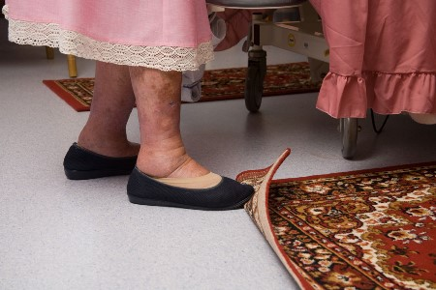
- Secure loose area rugs with double-faced tape, tacks, or slip-resistant backing.
- Do not sit in a chair or on a sofa that is so low that it is difficult to stand up.
- Repair loose wooden floorboards right away.
- Remove door sills higher than a half inch.

Kitchen
- Remove throw rugs.
- Clean up immediately any liquids, grease, or food spilled on the floor.
- Store food, dishes, and cooking equipment within easy reach.
- Do not stand on chairs or boxes to reach upper cabinets.
- Use nonskid floor wax.

Stairs
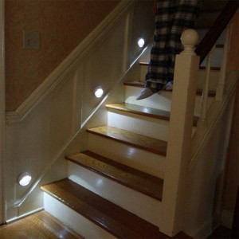
- Keep stairs clear of packages, boxes, or clutter
- Light switches should be at the top and bottom of the stairs. Or, consider installing motion-detector lights which turn on automatically when someone walks by.
- Provide enough light to clearly see each stair and the top and bottom landings.
- Keep flashlights nearby in case of a power outage.
- Remove loose area rugs from the bottom or top of the stairs.
- Replace patterned, dark, or deep-pile carpeting with a solid color, which will show the edges of steps more clearly.
- Put non-slip treads on each bare-wood step.
- Install handrails on both sides of the stairway. Each should be 30 inches above the stairs and extend the full length of the stairs.
- Repair loose stairway carpeting or wooden boards immediately.

Bathroom
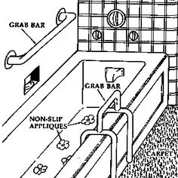
- Place a slip-resistant rug adjacent to the bathtub for safe exit and entry.
- Mount a liquid soap dispenser on the bathtub/shower wall.
- Install grab bars on the bathroom walls.
- Keep a nightlight in the bathroom.
- Use a rubber mat or place nonskid adhesive textured strips inside the tub.
- Replace glass shower enclosures with non-shattering material.
- Stabilize yourself on the toilet by using either raised seat or a special toilet seat with armrests.
- Use a sturdy, plastic seat in the bathtub if you cannot lower yourself to the floor of the tub or if you are unsteady.

What Can Happen After a Fall?
Many falls do not cause injuries. But one-out-of-five falls does cause a serious injury such as a broken bone or a head injury. These injuries can make it hard for a person to get around, do everyday activities, or live on their own.

- Falls can cause broken bones, like wrist, arm, ankle, and hip fractures.
- Falls can cause head injuries. These can be very serious, especially if the person is taking certain medicines (like blood thinners). An older person who falls and hits their head should see their doctor right away to make sure they don’t have a brain injury.
- Many people who fall, even if they’re not injured, become afraid of falling. This fear may cause a person to cut down on their everyday activities. When a person is less active, they become weaker and this increases their chances of falling.
How to fall
- Do not extend your arms to break the fall. Instead, raise an arm to protect your head.
- Try to fall on your side or buttocks and roll over naturally.
What to Do If You Fall
- Do not panic. Assess the situation and determine if you are hurt.
- Slide or crawl along the floor to the nearest couch or chair and try to get up.
- If you cannot get up, call for help.
- If you are alone, slowly crawl to the telephone and call 911 or relatives.

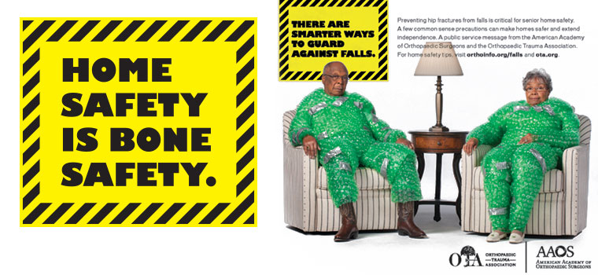

Resources:
- http://www.cdc.gov/steadi/patient.html
- http://www.cdc.gov/homeandrecreationalsafety/falls/adultfalls.html
- http://orthoinfo.aaos.org/topic.cfm?topic=a001355
- http://orthoinfo.aaos.org/falls

