Exercise | Time/Reps | Instruction | Illustration
Slow Jog | 1 min x 2 | Maintain good running form.
Arm Hugs | 30 s | Alternate arms over and under and slowly increase range of motion.  Dynamic Stretching Warm-up | 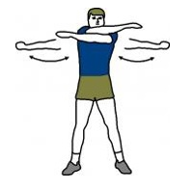
Arm Circles | 30 s each direction | Circle arms forward and then backward. Gradually increase motion from small to large circles. | 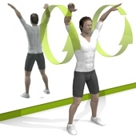
Bent Over Torso Twist | 30 s | Touch opposite hand and foot keeping your back straight and core engaged. Extend arms as long and straight as possible and keep knees straight. | 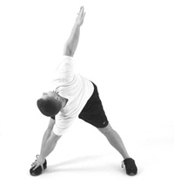
Walking Leg Kicks | 30 s x 2 | Stand tall, keep knees straight, and flex foot back. Reach for your foot and alternate legs. | 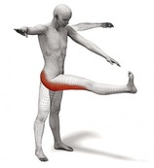
Leg Swings | 15 s each leg and side | Stand tall keeping your back straight. Perform kicks to the front, back, and side separately. Hold onto something for support. | 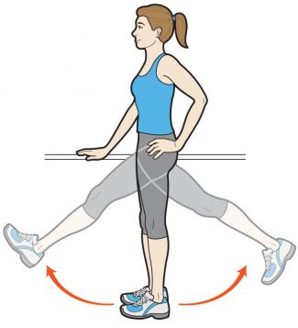
High Knee Walk | 30 s x 2 | Stand tall and lift knee as high as possible with foot flexed. Hug knee into body for a more advanced version if you are more flexible. | 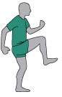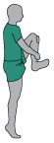
Lateral High Knee Jog | 30 s x 2 | Stand tall and run side to side with small, quick steps while lifting knees as high as possible. | 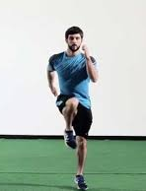
Bodyweight Squat | 10 reps x 2 | Feet shoulder width and keep weight in your heels. Push back hips as if sitting in a chair and make sure knees stay in line with second toe but do not advance in front of toes. Try to get thighs parallel to the ground with chest lifted and back straight. Push through the heels and return to standing. Travel laterally to make the movement more dynamic. | 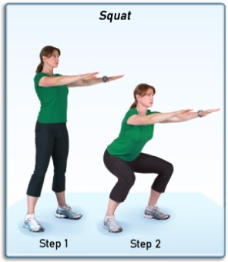
Walking Lunge Twist | 10 reps x 2 | Lunge walk forward or backward. Knee should align with second toe and not advance in front of toes. Twist to same side as front leg (ex. If R leg is in front, twist to the R). | 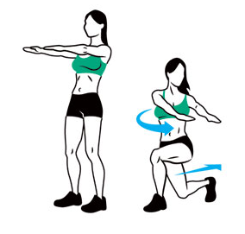
Side Lunge | 10 reps x 2 | Take a large step to the right, bend right knee and push back hips as if sitting in a chair. Keep hips facing to the front, right knee in line but behind toes, and chest up. Push through the heel and bring left leg to meet right back to the starting position. | 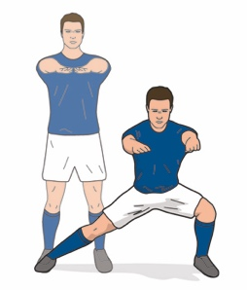
Back Pedal Run | 30 s x 2 | Run backward maintain good running form. | 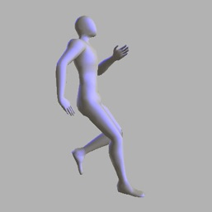
Inch Worm | 5 x 2 | Pike down to the floor with legs straight and place hands on the floor. Walk hands out, keeping legs straight, until you reach a push-up position. Then walk feet to hands, trying to keep feet as straight as possible, and repeat. Add a push-up in between for a more advanced version. | 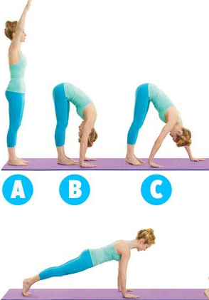
Glute Bridge | 15 x 2 | Lift hips to create a straight line through the knees, hips, shoulders. Keep back flat with glutes and abdominal muscles activated throughout the movement. Hold the movement for 1 s and repeat. | 