Core Strengthening Exercises
Purpose of Strengthening Core Muscles:
The deep muscles of your abdomen and low back (core muscles) are important for healthy breathing, coordinated control of your arms and legs, and maintaining good posture. A strong core will help minimize injury during bending and lifting activities. The following exercises serve as a starting point to building a strong and stable core upon which harder abdominal and full body exercises can be graduated to. It is important to breathe deeply and in a controlled manner during all exercises. Holding your breath may lead to injury.

Unless otherwise stated, repeat each exercise for a target of 10-12 repetitions. Begin with one exercise from each body area and gradually increase to all exercises listed.

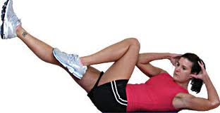
Abdominal Exercises:
- Bicycle Maneuver – Lie flat on the floor with your lower back pressed to the ground. Put your hands beside your head. Bring knees up to about 45- degree angle and slowly go through a bicycle pedal motion. Touch your left elbow to your right knee, then your right elbow to your left knee. Keep even, relaxed breathing throughout.

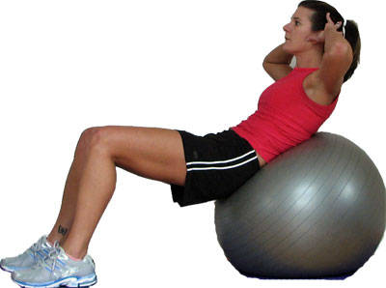
- Crunch on Exercise Ball – Sit on the ball with your feet flat on the floor. Let the ball roll back slowly. Now lie back on the ball until your thighs and torso are parallel with the floor. Cross your arms over your chest and slightly tuck your chin in toward your chest. Contract your abdominals raising your torso to no more than 45 degrees. For better balance, spread your feet wider apart. To challenge the obliques, make the exercise less stable by moving your feet closer together. Exhale as you contract; inhale as you return to the starting position.

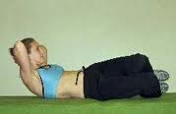
- Side Crunches – Side crunches target the internal and external obliques. Lie on your back with your knees bent. Rotate hips and knees until both knees are turned to the right side and touching the ground. Lift your shoulder blades off the floor and exhale as you come up. Hold position for one second and lower your shoulders back to starting position. Repeat eight to 15 times, then switch to opposite side.

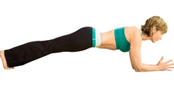
- Planks – Place your elbows on the floor underneath your shoulders and your toes on the floor with legs hip width apart. With back straight, lift your body off the floor and pull in your belly button towards your spine. Hold this position for a count of 30 to 60 seconds. Relax placing your body back on the floor and then repeat for 3 to 5 repetitions. Note: Remember to breathe while you are holding your position and keep your back straight and parallel to the ground. For increased challenge, you can also do this as a straight arm plank pose, placing your hands on the floor instead of your elbows.
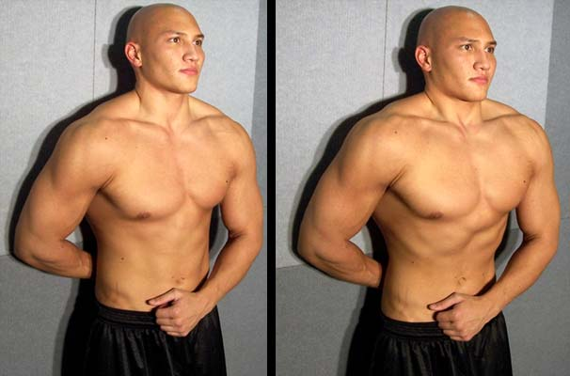
- Stomach Vacuum – The stomach vacuum is a weightless exercise you can perform to improve the strength of your transverse abdominis and improve the appearance of your core. The stomach vacuum is performed by standing upright and exhaling completely. Draw in your stomach as much as possible and puff out your chest and hold the position for as long as possible. You can also perform the stomach vacuum while sitting, lying or kneeling.

Low Back Exercises:
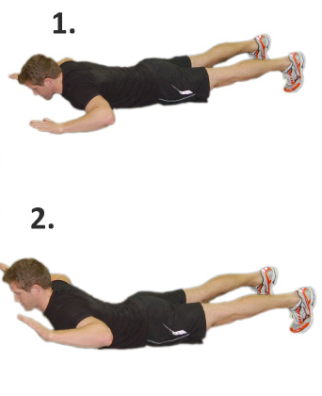
- Dorsal Raise (Low Back Extensions) – Lie down on your front with your arms down by your side. Keep your head facing the floor throughout the exercise. Now raise your shoulders and chest off the floor as high as you can get them only using your lower back muscles. DO: keep your head facing downwards throughout the exercise, breathe out on the way up and in on the way down, and keep the movement slow and controlled. DON’T: arch your head back, hold your breath, or rush the exercise.
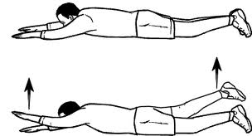
- Supermans – This is a body-weight exercise executed from a face-down position on the floor. The important thing with this exercise is to keep your torso down on the floor at all times. After moving your legs about hips-width apart behind you, raise your left arm and right leg about 6 inches off the floor. Hold for five to 10 seconds, slowly lower and repeat with your opposite side. Alternate back and forth for a set of repetitions. You also activate your hamstrings and glutes with this exercise.
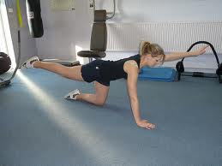
- Opposite Arm and Leg Raise – Opposite arm and leg raises are similar to Supermans, but they are executed from an all-fours position. Before you start the exercise, make sure your hands are under your shoulders and knees are under your hips. Steadily raise your left arm straight in front of your body, and extend your right leg straight behind you. After holding for a full second, lower your arm and leg and repeat on your other side. Alternate back and forth in a steady and controlled motion. You also work your abdominals in this exercise.

Buttocks and Pelvic Exercises:
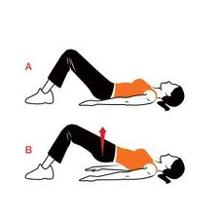
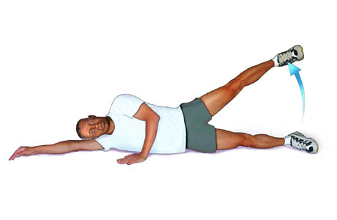
- Gluteal Lift (Bridge) – The basic glute bridge is done on the floor with both legs and without additional elements of instability. Lie on your back with your knees bent and your feet flat on the floor, hip-width apart and parallel to one another. Relax your arms at your sides, palms face down. Draw your abdominal muscles in and tilt your pelvis up toward your torso to press your lower back into the floor. With both shoulder blades in full contact with the floor, inhale, then exhale and lift your hips up by contracting your gluteal muscles. Simultaneously push your heels against the floor to stabilize your legs. Your body should form a straight line from your shoulders to your knees. Hold the position, lower with control and repeat for 10-12 repetitions.
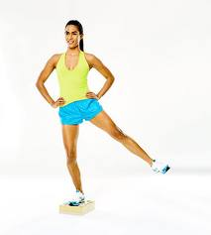
- Standing/Lying Abduction – Standing and lying hip abduction is done with body weight or with resistance. From a standing position, lift and lower your left leg laterally in the air as high as possible for a set of reps, then switch sides. To do these lying down, lie on your left side with your legs stacked, then lift and lower your right leg in the air. After doing a set of reps, switch sides. To increase the resistance with both exercises, strap any form of resistance bands around your ankles or fasten ankle weights to your lower legs. Perform 10 to 12 repetitions with any variation.

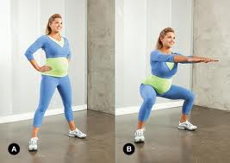
- Plie Squat – The wide stance and toe positioning during plie squats activates and uses the adductors. Stand up straight. Widen your stance until your feet are slightly wider than your shoulders. Rotate your heels outward, turning your toes until they form a 45-degree angle. Lift your arms directly in front of your body, stopping when they are parallel to the floor. Stick your butt out and lower your hips toward the ground. Protect your knees--try to align your knees with your small toes as you lower your body. Stop when the backs of your legs are parallel to the ground. Push up through your heels to return to standing. Complete 15 repetitions.
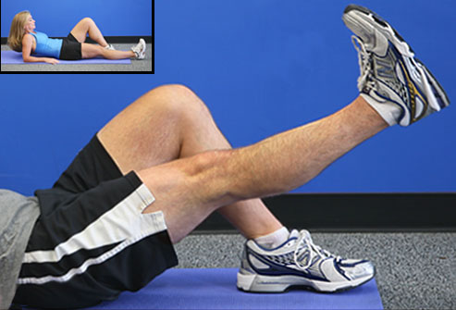
- Straight Leg Raises – Straight leg raises focus on isolating the psoas, while using the iliacus for support. To raise the difficulty of the workout, use different ankle weights and avoid free weights, particularly if you suffer from back problems; you will find ankle weights more efficient and comfortable. Start the workout lying on your back, arms at your sides, with one leg extended and the other bent at a 45-degree angle. Contract the quadriceps of your working leg, keeping your working knee straight and grounded-leg knee bent, and lift your leg off the ground until your thighs are parallel with each other. Relax briefly and return to starting position. Focus on contracting your working-leg quadriceps and keeping the other knee bent; the working knee bends slightly due to fatigue or exhausted quadriceps. Perform one to three sets of 10 to 15 repetitions each.

