Basic Bicycle Fitting Instructions
The bike fitting process can be very complicated. Use this handout as a guide to get started. One great website to visit first for a more comprehensive overview is BikeFit, http://www.bikefit.com/s-13-road-bikes.aspx. Then make an appointment at your local bike store to get an expert opinion.
Every individual has their own cycling needs and specifications. This handout focuses on proper bike fitting and not sizing. To start, you want to make sure the primary contact points between the cyclist and bike are perfect, including the pelvis, hands and feet. Proper alignment may be achieved by adjusting the saddle, handlebars, brake levers and hoods, stem, shoes, cleats and pedals. It may take many weeks of fine tuning, but eventually you will no longer notice the bike and simply enjoy your ride!
- Pelvis
  - Saddle Selection:
    - This is an important first step because it is time consuming to change one. Sitting on several types is the best way to gauge your comfort level of firmness, width (try both men and women’s styles) and cutout.
    - Next determine the height. Sit on the saddle with one leg straight down. Your heel should just touch the pedal at the lowest point, but when ball of foot is moved to the center of the pedal your knee should have a slight bend (153-143°).
    - Fore/Aft position is determined by the knee over pedal spindle (KOPS). With pedals level your knee cap should be directly over the center of the pedal.

- Hands
  - Handlebar Position:
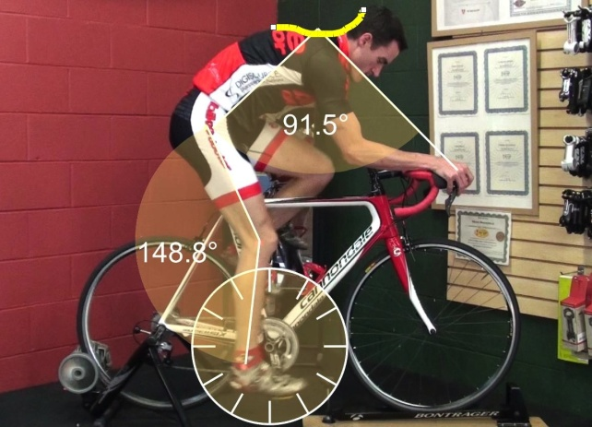
    - Comprised of height, depth, width and brake type/position. Make subtle adjustments to the stem, handlebars and brake lever hoods. Ideally the torso and upper arm angle should be about 90° and elbows should be slightly bent to about 15°.
    - Typically the handlebars are below the seat height for racers and even or above the seat for non-racers. Riding more upright may need an angle <90°.

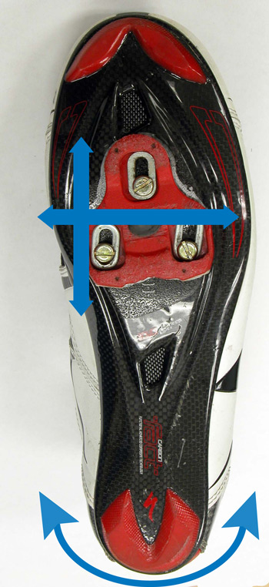
- Feet
  - Cleat/Pedal connection: Most important aspect!
    - Fore/aft position may vary from behind the ball of the foot to near the pinky toe.
    - Side-to-side placement is gauged by looking at the knee over toe alignment during pedaling. If the knee leans to the outside, adjust cleat inward and vice versa. This may also require longer pedals or spacers.
    - Tilt angle can further relieve pressure points, ie “hot foot.” Several wedge types are available to help balance your foot on the pedals.
    - Foot rotation is another adjustment made to your cleat to make sure your feet point straight ahead on the pedals.
  - Crank Length:
    - A less critical factor and generally the factory ones are fine. Ie. Shorter height uses shorter crank arms and taller people use longer ones.
  - Leg length discrepancies should be addressed by a specialist.
  - Frame size is important only as far as getting an appropriate range and the detailed adjustments discussed above tailor the fit to your specifications. Most people do not require custom frames.

Overall, have fun with it and don’t be afraid to make adjustments. Seeking advice from a well-trained bike fitter can expedite the process.

A quick troubleshooting reference chart (courtesy of BikeFit):
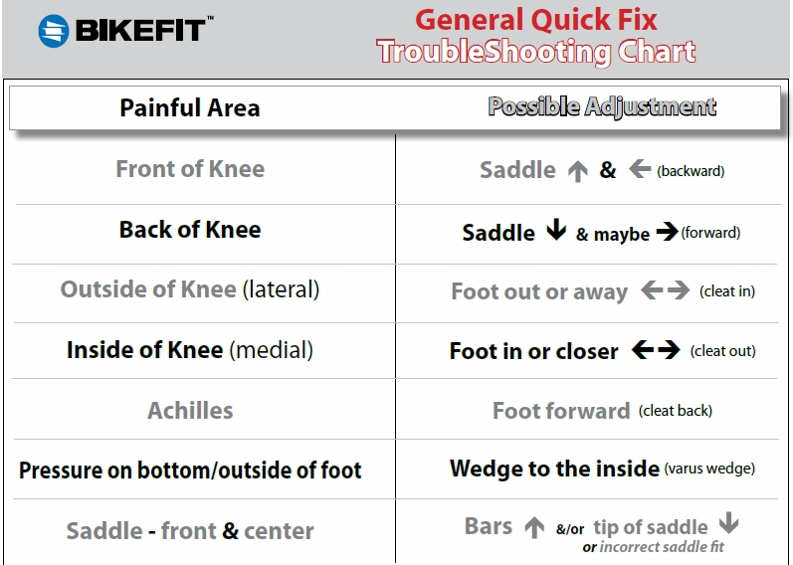

Document created by Melanie Gray, DO, PGY3; July 2014

