Pediatric Apophysitis

What is an apophysis?
An apophysis is the area where a tendon inserts into bone, connecting muscle to the bone. These bony areas are not fused in children, and will fuse as we get older in adolescence and into our young adult years.

Why are they causing my child pain?
These are areas that are stressed during exercise due to the forces they transmit. Usually they are able to handle the strain during exercise, but children can have some inflammation in that area particularly during growth spurts. Girls are most often affected from age 8-13 and boys from age 9-14. As your child grows the bones will often grow faster than the muscles and tendons. This puts a strain on the muscles and tendons that can cause them to become inflamed more easily, leading to your child’s pain, particularly after periods of high activity. This process can occur anywhere in the body and has several different names depending on the affected area. The two most common areas of apophysitis are:

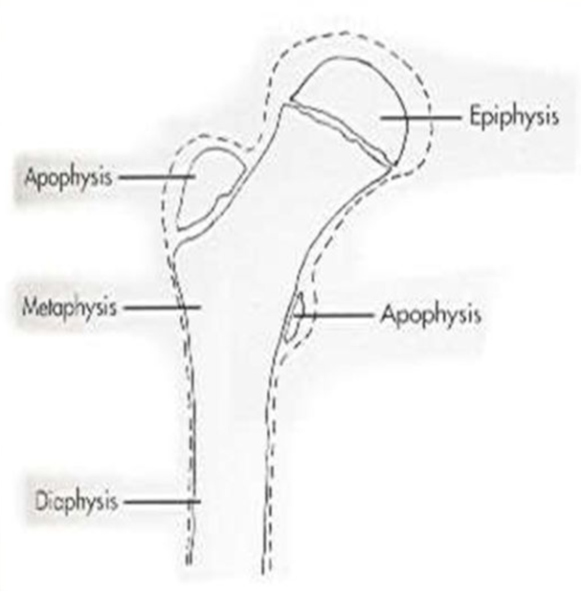
- Heel (Calcaneal apophysitis) – Sever’s disease
- Knee (Patellar apophysitis) – Osgood-Schlatter disease

More information about these conditions can be found at www.kidshealth.org

Will this cause permanent injury to my child?
No, these injuries are due to the extra strains on the apophyseal growth plate on your child and will improve as your child becomes older and his/her growth slows.

What do I need to do to care for my child?
This will get better over time, but there are things that you can do to help care for your child. Apophysitis is often considered an overuse injury so rest is the most important part of treatment:

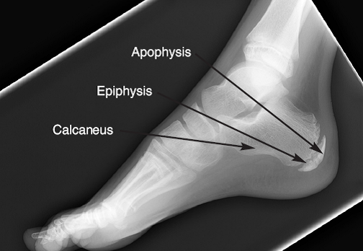
- Limiting sports and physical activity allow the area to rest and the body to resolve inflammation in the affected area. Usually 2-4 weeks of rest is needed, but I will help you tailor this to your child and their individual situation. When discussing return to play we use the acronym FITT.
- Stretching exercises will help to reduce muscle tension and pain
- Ice will help to reduce inflammation
- Heel lifts and other paddings can help to reduce impacts, particularly for Sever’s Disease
- Occasionally a brace or cast may be needed to restrict motion while the affected area heals, but most cases will resolve with rest
- Medications such as ibuprofen (Advil, Motrin) or acetaminophen (Tylenol) may be used to reduce inflammation and pain but are often not needed

